#1. provide the list of markets in which customer "Atliq Exclusive" operates its business in the APAC region

select distinct market

from dim_customer

where customer ='Atliq Exclusive' and region='APAC'

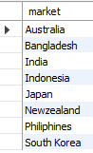

2. What is the percentage of unique product increase in 2021 vs. 2020? The

final output contains these fields,

unique_products_2020 ,unique_products_2021, percentage_chg

SELECT X.A AS unique_product_2020, Y.B AS unique_products_2021, ROUND((B-A)*100/A, 2) AS percentage_chg

FROM

(

(SELECT COUNT(DISTINCT(product_code)) AS A FROM fact_sales_monthly

WHERE fiscal_year = 2020) X,

(SELECT COUNT(DISTINCT(product_code)) AS B FROM fact_sales_monthly

WHERE fiscal_year = 2021) Y

)



/*3. Provide a report with all the unique product counts for each segment and

sort them in descending order of product counts. The final output contains

2 fields, Segment ,product_count*/

SELECT segment, COUNT(DISTINCT(product_code)) AS product_count FROM dim_product

GROUP BY segment

ORDER BY product_count DESC ;

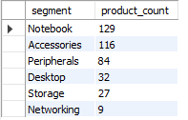

/*4. Follow-up: Which segment had the most increase in unique products in

2021 vs 2020? The final output contains these fields,

Segment, product_count_2020, product_count_2021, difference*/

WITH CTE1 AS

(SELECT P.segment AS A , COUNT(DISTINCT(FS.product_code)) AS B

FROM dim_product P, fact_sales_monthly FS

WHERE P.product_code = FS.product_code

GROUP BY FS.fiscal_year, P.segment

HAVING FS.fiscal_year = "2020"),

CTE2 AS

(

SELECT P.segment AS C , COUNT(DISTINCT(FS.product_code)) AS D

FROM dim_product P, fact_sales_monthly FS

WHERE P.product_code = FS.product_code

GROUP BY FS.fiscal_year, P.segment

HAVING FS.fiscal_year = "2021"

)

SELECT CTE1.A AS segment, CTE1.B AS product_count_2020, CTE2.D AS product_count_2021, (CTE2.D-CTE1.B) AS difference

FROM CTE1, CTE2

WHERE CTE1.A = CTE2.C ;

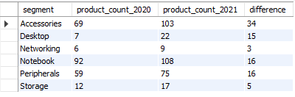

/*5.Get the products that have the highest and lowest manufacturing costs.

The final output should contain these fields, product_code product manufacturing_cost*/

select product,p.product_code,manufacturing_cost

from fact_manufacturing_cost mc join dim_product p

on mc.product_code=p.product_code

WHERE manufacturing_cost=(SELECT MAX(manufacturing_cost) FROM fact_manufacturing_cost)

OR manufacturing_cost=(SELECT MIN(manufacturing_cost) FROM fact_manufacturing_cost)



/*6.Generate a report which contains the top 5 customers who received an average high pre_invoice_discount_pct for the fiscal year 2021 and in the Indian market.

The final output contains these fields

customer_code ,customer, average_discount_percentage*/

SELECT c.customer_code ,customer, avg(pre_invoice_discount_pct) as average_discount_percentage

FROM dim_customer C JOIN fact_pre_invoice_deductions pid on c.customer_code=pid.customer_code

where fiscal_year=2021 and market='India'

group by c.customer_code ,customer

order by average_discount_percentage desc limit 5

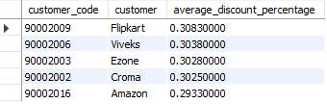

/*7. Get the complete report of the Gross sales amount for the customer “Atliq

Exclusive” for each month. This analysis helps to get an idea of low and

high-performing months and take strategic decisions.

The final report contains these columns:

Month, Year, Gross sales Amount*/

SELECT CONCAT(MONTHNAME(FS.date), ' (', YEAR(FS.date), ')') AS 'Month', FS.fiscal_year,

ROUND(SUM(G.gross_price*FS.sold_quantity), 2) AS Gross_sales_Amount

FROM fact_sales_monthly FS JOIN dim_customer C ON FS.customer_code = C.customer_code

JOIN fact_gross_price G ON FS.product_code = G.product_code

WHERE C.customer = 'Atliq Exclusive'

GROUP BY Month, FS.fiscal_year

ORDER BY FS.fiscal_year ;

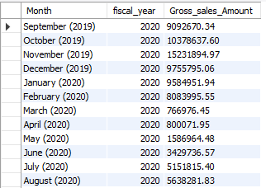

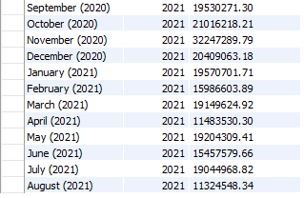

8. /*8. In which quarter of 2020, got the maximum total_sold_quantity? The final

output contains these fields sorted by the total_sold_quantity,

Quarter, total_sold_quantity*/

SELECT

CASE

WHEN date BETWEEN '2019-09-01' AND '2019-11-01' then 1

WHEN date BETWEEN '2019-12-01' AND '2020-02-01' then 2

WHEN date BETWEEN '2020-03-01' AND '2020-05-01' then 3

WHEN date BETWEEN '2020-06-01' AND '2020-08-01' then 4

END AS Quarters,

SUM(sold_quantity) AS total_sold_quantity

FROM fact_sales_monthly

WHERE fiscal_year = 2020

GROUP BY Quarters

ORDER BY total_sold_quantity DESC

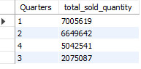

/*9. Which channel helped to bring more gross sales in the fiscal year 2021

and the percentage of contribution? The final output contains these fields,

channel, gross_sales_mln, percentage*/

WITH Output AS

(

SELECT C.channel,

ROUND(SUM(G.gross_price*FS.sold_quantity/1000000), 2) AS Gross_sales_mln

FROM fact_sales_monthly FS JOIN dim_customer C ON FS.customer_code = C.customer_code

JOIN fact_gross_price G ON FS.product_code = G.product_code

WHERE FS.fiscal_year = 2021

GROUP BY channel

)

SELECT channel, CONCAT(Gross_sales_mln,' M') AS Gross_sales_mln , CONCAT(ROUND(Gross_sales_mln*100/total , 2), ' %') AS percentage

FROM

(

(SELECT SUM(Gross_sales_mln) AS total FROM Output) A,

(SELECT * FROM Output) B

)

ORDER BY percentage DESC

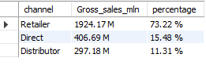

10 /*10. Get the Top 3 products in each division that have a high

total_sold_quantity in the fiscal_year 2021? The final output contains these

fields,

division, product_code, product, total_sold_quantity, rank_order*/

WITH Output1 AS

(

SELECT P.division, FS.product_code, P.product, SUM(FS.sold_quantity) AS Total_sold_quantity

FROM dim_product P JOIN fact_sales_monthly FS

ON P.product_code = FS.product_code

WHERE FS.fiscal_year = 2021

GROUP BY FS.product_code, division, P.product

),

Output2 AS

(

SELECT division, product_code, product, Total_sold_quantity,

RANK() OVER(PARTITION BY division ORDER BY Total_sold_quantity DESC) AS 'Rank_Order'

FROM Output1

)

SELECT Output1.division, Output1.product_code, Output1.product, Output2.Total_sold_quantity, Output2.Rank_Order

FROM Output1 JOIN Output2

ON Output1.product_code = Output2.product_code

WHERE Output2.Rank_Order IN (1,2,3)

